**Q10. Implement ACLs to restrict traffic based on source and destination ports. Test rules by simulating legitimate and unauthorized traffic.**

**Network setup:**

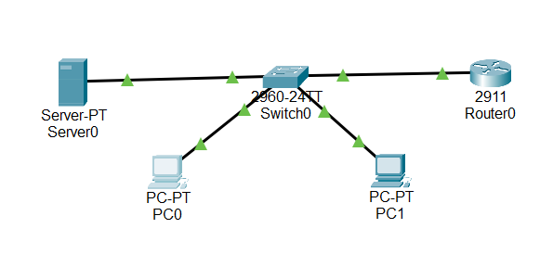

**Switch configuration:**

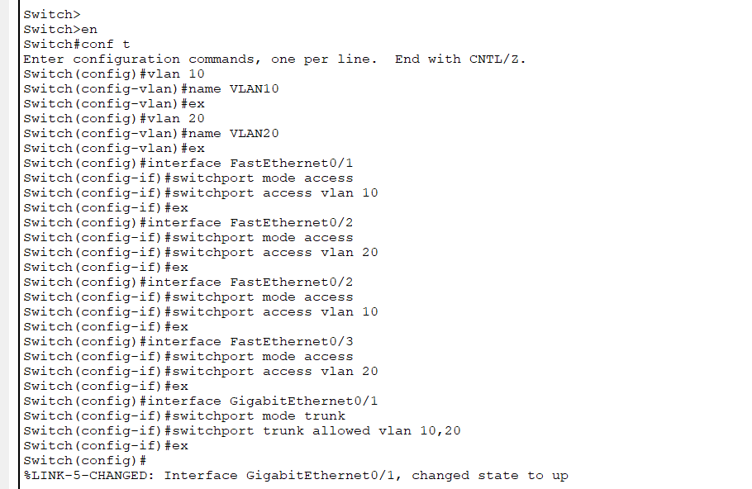

**Router configuration and ACL configuration:**

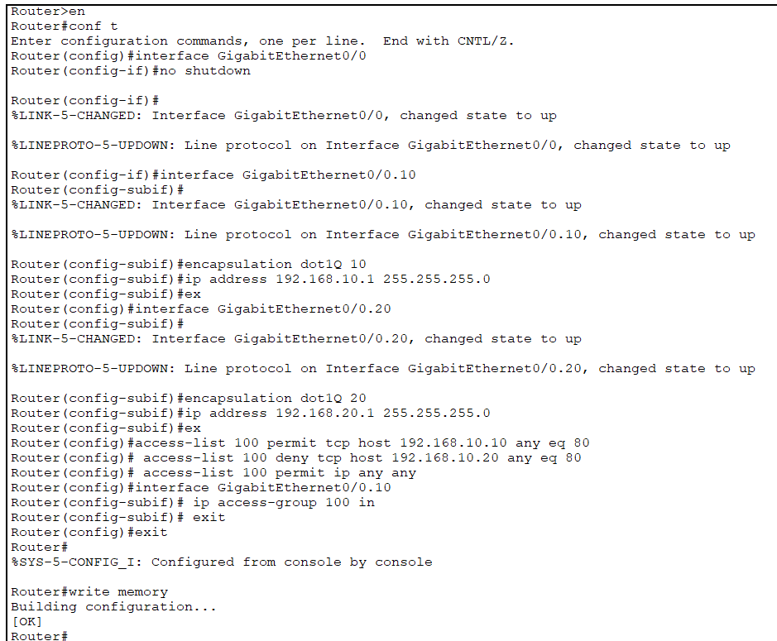

**Verififications:**

1. **Permitted in PC0:**

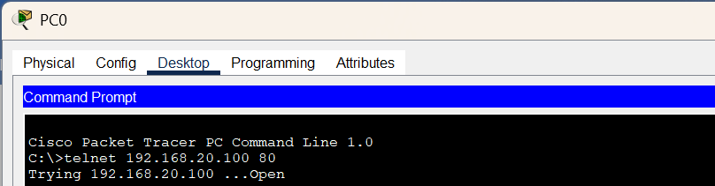

1. **Blocked for PC1:**

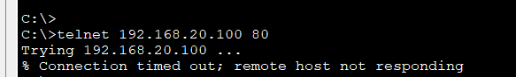

**To ensure PC2 can still ping the server:**

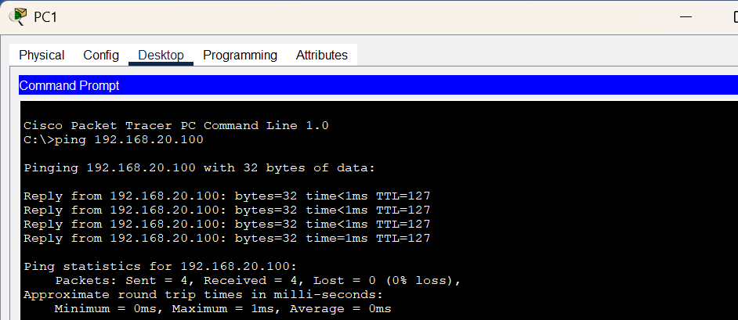

**Access table:**

